Practical - 3
Practical Title: Responsive UI Design using CSS Grid, Flexbox, and Bootstrap/Tailwind
Problem Definition: Design responsive layouts for Home, About, Registration, Dashboard, and Events pages using CSS Grid and Flexbox. Optional to use CSS framework such as Bootstrap or Tailwind. Ensure mobile-first responsiveness.
1. How does the layout adapt for mobile, tablet, and desktop screens?
Answer: The layout follows a mobile-first approach. The base CSS is written for small screens: a single-column layout with the navigation links stacked vertically. Two min-width media queries then enhance it. At 768px and above (tablet) the navigation becomes a horizontal row, the card grid shows 2 columns, the registration form shows 2 columns and the footer content moves into a row. At 1024px and above (desktop) the card grid shows 3 columns and the dashboard gets a fixed 240px sidebar next to the main content.
2. Which layout technique is used and why?
Answer: Both modern CSS layout systems are used, each where it fits best. Flexbox is used for one-dimensional layouts: the navbar, the footer, form fields (label above input) and the centred hero content. CSS Grid is used for two-dimensional layouts: the cards on the Home, About and Events pages, the two-column registration form, the statistics boxes (repeat(auto-fit, minmax(150px, 1fr))) and the sidebar plus content structure of the dashboard. Grid is used for page and card layouts because it controls rows and columns together, while Flexbox is better for aligning items in a single row or column.
3. Are typography, spacing, colors, and contrast readable?
Answer: Yes. A system font stack (system-ui, Segoe UI, Roboto, Arial) is used with a 1.6 line-height for readable body text, and the main heading uses clamp(1.75rem, 5vw, 3rem) so it scales smoothly with the screen. Spacing is consistent: a single --gap variable (1rem) is used between grid items, and padding/margin are set in rem units. Colours are kept in CSS custom properties (--primary #1e3a8a, --accent #2563eb, --text #1f2937).
4. Is the framework used consistently without unnecessary inline CSS?
Answer: Yes. All pages (index, about, events, register, dashboard) link to the same external style.css and use the same reusable classes (.container, .grid, .card, .btn, .navbar, .site-footer), so the header, footer and components look identical across pages. There are no inline style attributes and no per-page <style> blocks; every colour and spacing value comes from the CSS variables or shared classes, which makes the CSS easy to maintain and change from one place.

B. Implementation / Output / Result
1. Project structure
practical3/
index.html (Home)
about.html (About)
events.html (Events)
register.html (Registration form)
dashboard.html (Dashboard)
style.css (shared mobile-first stylesheet)

2. index.html (Home page)
<!DOCTYPE html>
<html lang="en">
<head>
<meta charset="UTF-8">
<meta name="viewport" content="width=device-width, initial-scale=1.0">
<title>Home | StudentHub</title>
<link rel="stylesheet" href="style.css">
</head>
<body>
<header class="site-header">
<div class="container">
<nav class="navbar" aria-label="Main navigation">
<a class="brand" href="index.html">StudentHub</a>
<ul class="nav-links">
<li><a href="index.html">Home</a></li>
<li><a href="about.html">About</a></li>
<li><a href="events.html">Events</a></li>
<li><a href="register.html">Register</a></li>
<li><a href="dashboard.html">Dashboard</a></li>
</ul>
</nav>
</div>
</header>

<main>
<section class="hero">
<div class="container">
<h1>Welcome to StudentHub</h1>
<p>One portal for student registration, events and campus updates.</p>
<a class="btn" href="register.html">Register Now</a>
</div>
</section>

<section class="section">
<div class="container">
<h2>Features</h2>
<div class="grid">
<article class="card">
<h3>Easy Registration</h3>
<p>Create your student account in a few steps.</p>
</article>
<article class="card">
<h3>Campus Events</h3>
<p>Browse and join upcoming events.</p>
</article>
<article class="card">
<h3>Personal Dashboard</h3>
<p>Track your registrations in one place.</p>
</article>
</div>
</div>
</section>

<section class="section">
<div class="container">
<h2>Upcoming Events</h2>
<div class="grid">
<article class="card">
<h3>Tech Fest 2026</h3>
<p>15 Nov 2026 - Main Auditorium</p>
</article>
<article class="card">
<h3>Web Dev Workshop</h3>
<p>22 Nov 2026 - Lab 3</p>
</article>
<article class="card">
<h3>Hackathon</h3>
<p>05 Dec 2026 - Seminar Hall</p>
</article>
</div>
</div>
</section>
</main>

<footer class="site-footer">
<div class="container footer-inner">
<p>&copy; 2026 StudentHub. All rights reserved.</p>
<p>Faculty of Technology and Engineering, CHARUSAT</p>
</div>
</footer>
</body>
</html>

C. Evidence of Work (Screenshots)

About :

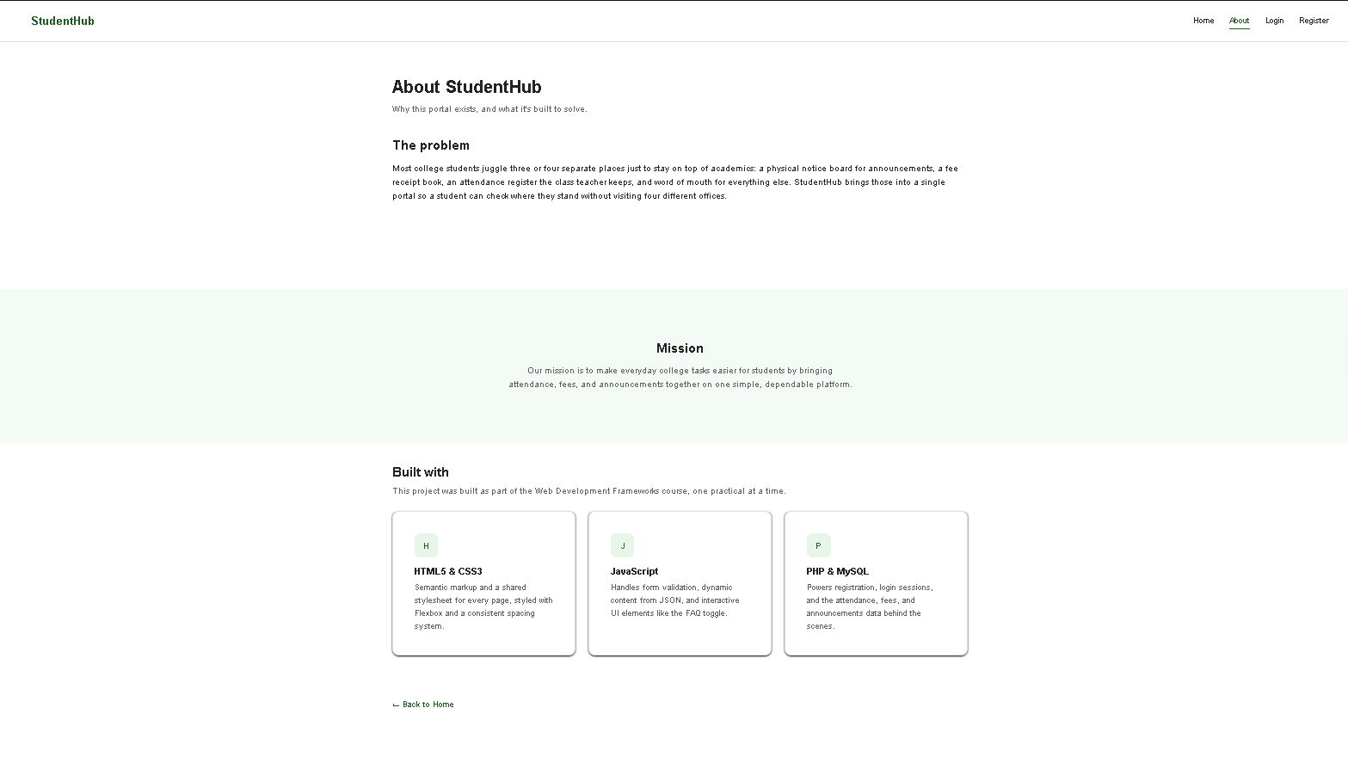

Announcements :

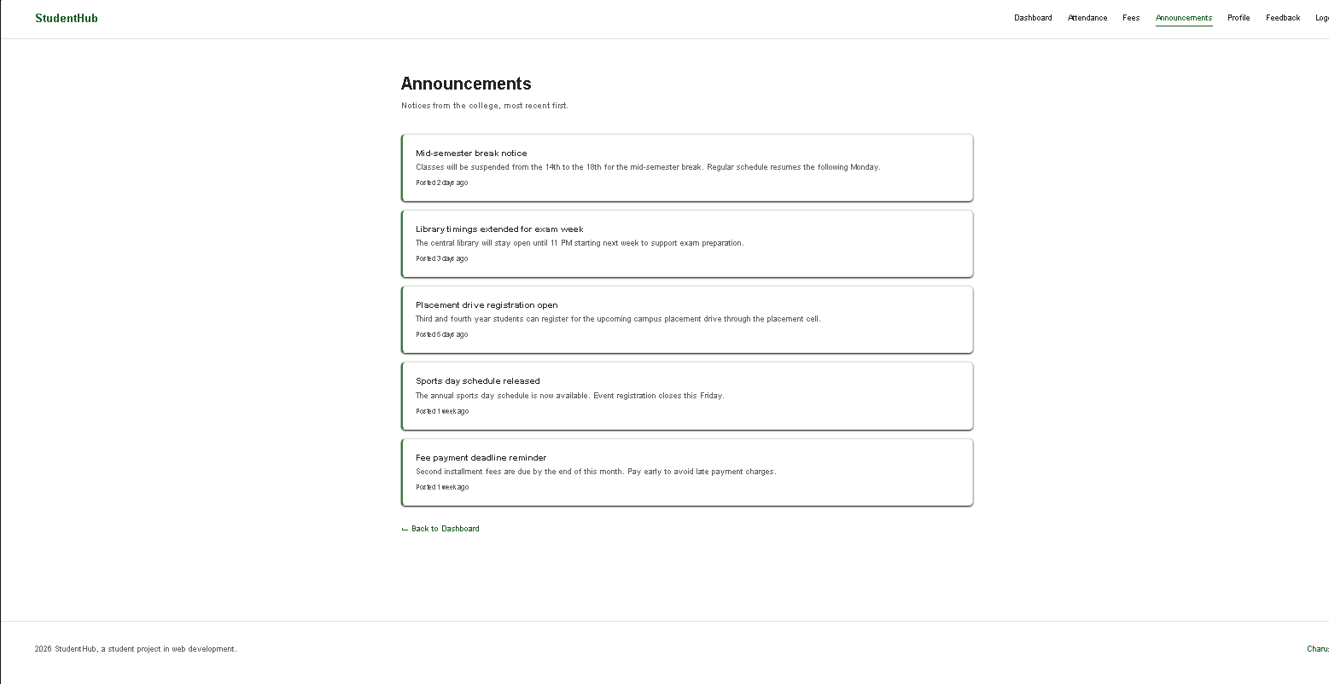

Attandance :
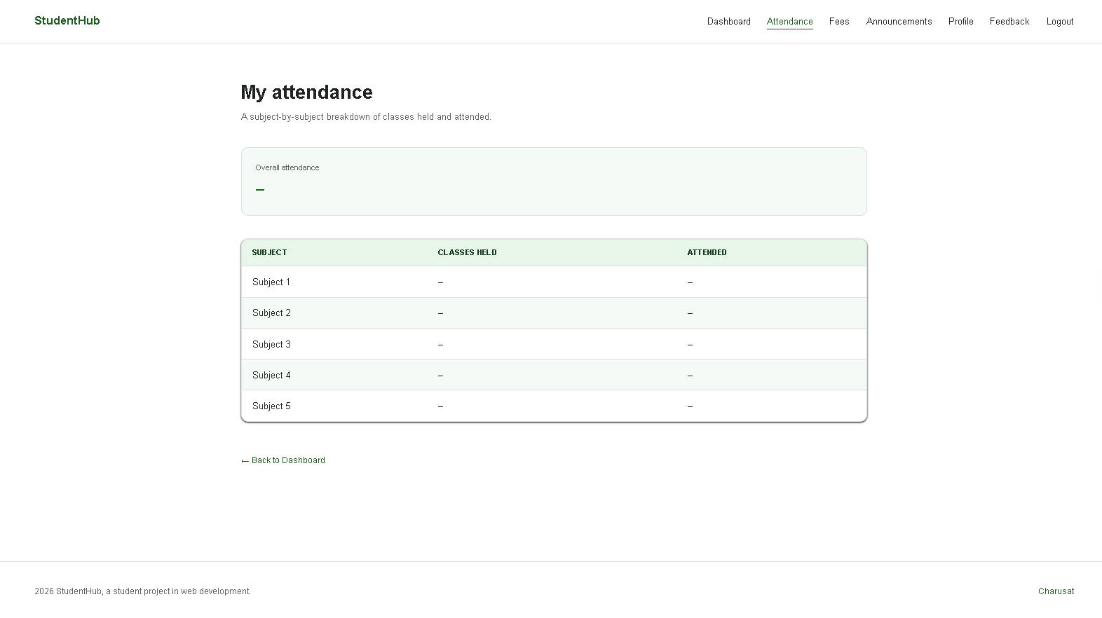

Dashboard :

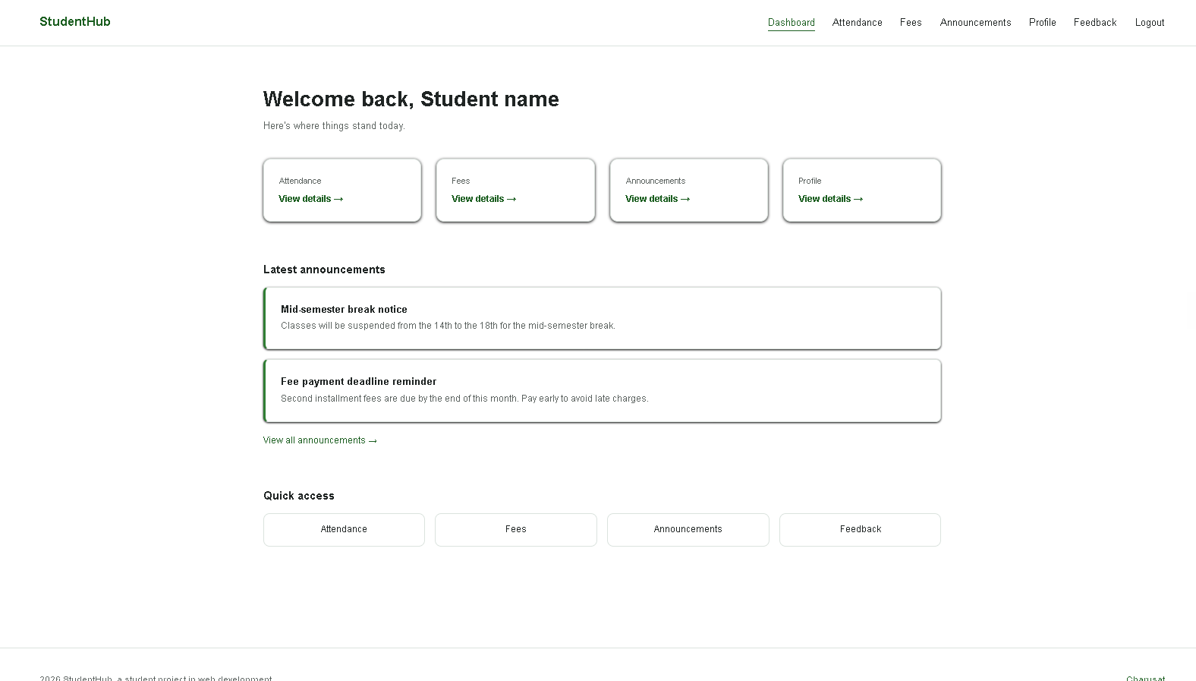

Feedback :
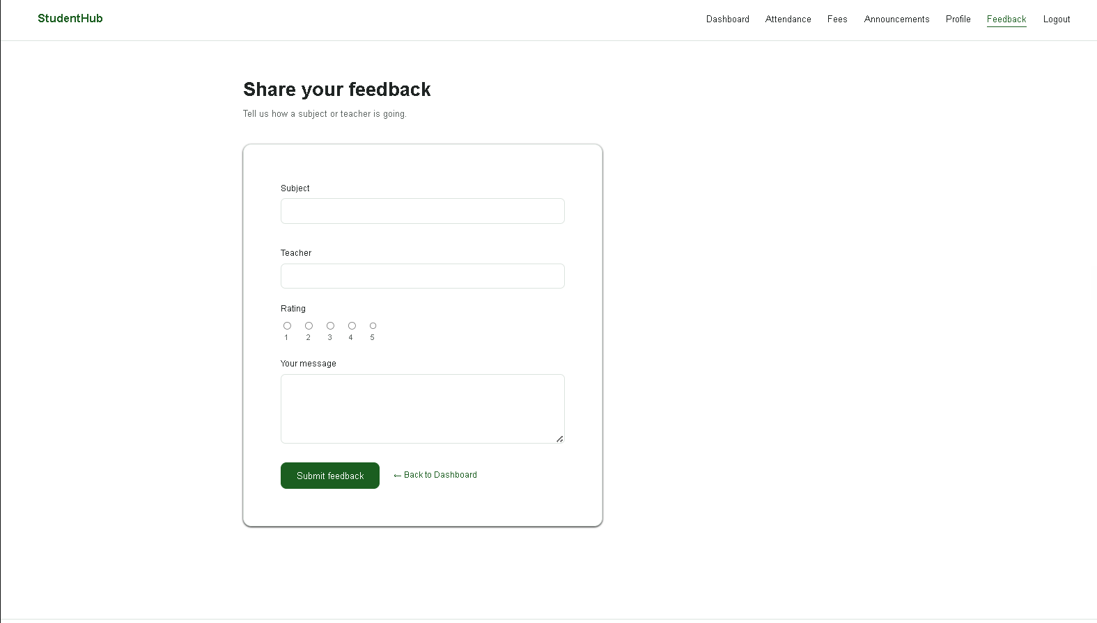

Login :

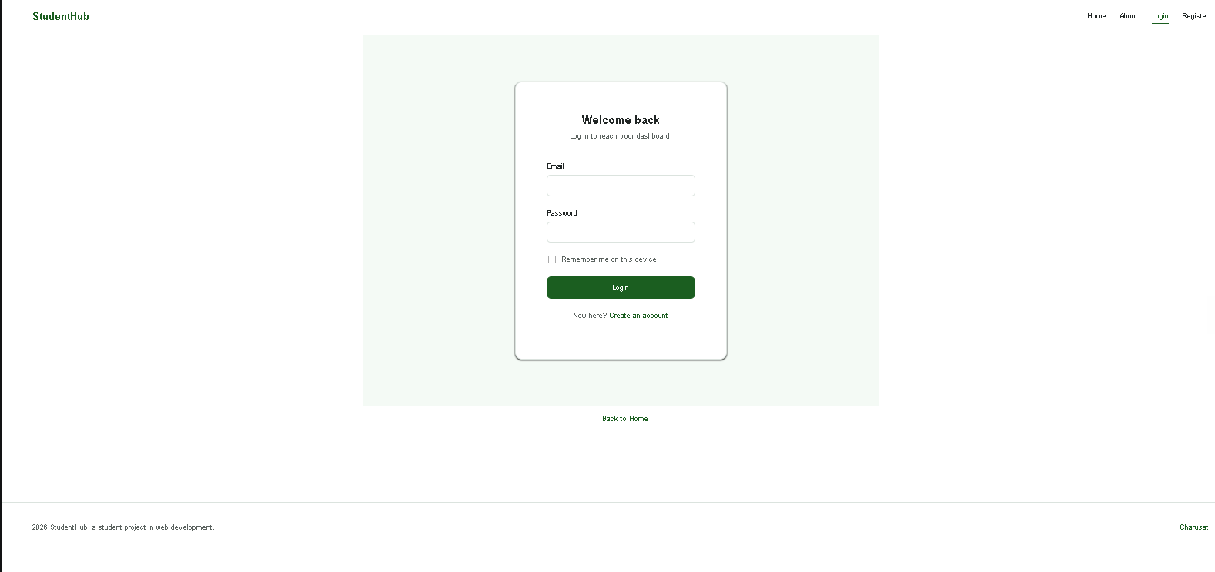

D. GitHub Repository Link :

https://github.com/kvvaghasiya49/Web_Development.git

E. Challenges Faced:
1. Choosing between Flexbox and Grid for each part of the page; this was solved by using Flexbox for one-directional rows/columns (navbar, footer, form fields) and Grid for card layouts and page structure.
2. Writing the CSS mobile-first. Starting from the small-screen layout and adding min-width media queries needed a change in thinking from the usual desktop-first way.
3. The layout was broken on a real phone screen at first because the viewport meta tag was missing; adding it fixed the scaling problem.
4. Making the card grid adjust smoothly between 1, 2 and 3 columns, and the dashboard sidebar collapse on small screens, without using fixed widths.
5. Keeping all pages visually consistent without inline CSS, and keeping text colours readable (contrast) on both the light and dark backgrounds.

F. Learning Outcomes:
1. I can build responsive, mobile-first page layouts using media queries, fluid units and the viewport meta tag.
2. I understand when to use CSS Flexbox (one-dimensional layouts) and CSS Grid (two-dimensional layouts), including repeat(), fr, minmax() and auto-fit.
3. I can organise CSS using custom properties and reusable classes in a single external stylesheet, with no inline styling.
4. I can choose readable typography, spacing and colour contrast, and test a design on different screen sizes using the browser responsive mode and DevTools.
5. I can create a consistent multi-page website (Home, About, Events, Registration, Dashboard) with a shared header, footer and navigation.

G. Faculty Remarks:

